Flashback Creatures
Zvi Mowshowitz
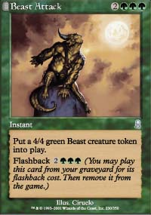
Odyssey is an assault on counterspells. As usual, many of the most powerful cards in the set are based on the new mechanics. Threshold is interesting concept as well, but the more important mechanic is flashback. Odyssey has twenty-six cards with flashback, and not all of them are worth playing. However, the better ones are very dangerous cards. Consider the cards that best illustrate the problem:
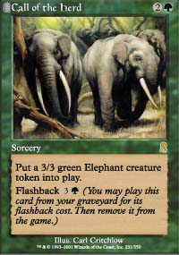
If Wild Mongrel is "the best bear ever printed," and it's certainly one of the better ones, Call of the Herd is the best creature of the line. Getting a 3/3 creature for three mana generally means dealing with a slight drawback, even for green. Silt Crawler taps all its controller's lands when it comes into play. Trained Armodon costs two colored mana. Chimeric Idol was probably thought to have a drawback when it was first printed, and tapping those lands can definitely be annoying. It turned out later that the Idol's ability to dodge removal spells was more than sufficient compensation. In other colors, the drawbacks get more serious.
Being a token is also a drawback. The most obvious reasons are the bounce spells. Recoil or Repulse a token and it goes away never to return, as will Wash Out. A more permanent source of bounce like Temporal Adept is even worse. A second problem is that tokens are considered to have a casting cost of zero, which leaves them especially vulnerable to cards like Pernicious Deed. To all of that I say "who cares?" Compared to the chance to get a second token, these risks are nothing.
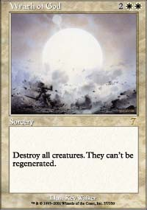
Consider the problem of a standard control deck trying to deal with Call of the Herd. It can be countered, but it would have to be countered twice. It can be bounced, but if the second token is held in reserve once the first enters play, it will require two separate bounce spells. There isn't all that much risk putting them both out at once, since only a select few spells can bounce both at once. Those that do exist are very hard for control decks to maindeck. A bigger risk is a spell like Wrath of God, but that risk applies to all other creatures as well. Getting two creatures for one card allows the envelope to be pushed in ways like that.
It boils down to the same problem. Call of the Herd is one card that creates two solid attackers, each for a very reasonable price. It also fits right into the green mana curve for Standard, playable on turns two and three with a Bird of Paradise or Llanowar Elves. No matter what approach the green mage takes, he has the advantage. He can try and provoke an early Wrath of God or similar spell. He can cast an attacker and hold the other in reserve in the graveyard. He can even hold them both back for later, while he pursues his early game plan and draws out bounce spells, since bounce generally gets used early to buy time. What is there to do about it?
Option one is just to deal with it directly. The control player can reconcile himself with taking a two for one hit whenever Call of the Herd appears, and make up for it with his own card advantage elsewhere. He can use bounce spells, but that means playing cards that don't really fit in the deck otherwise. Even if they line up properly, he'll need to draw two of them to do better than break even, and even then they have to be cantrips. In short, this is Magic's general nightmare scenario, where even the dedicated solution gives up power and flexibility elsewhere in the hopes of not being hurt by the threat. The one good answer is Syncopate, which is reminiscent of Dissipate facing down Hammer of Bogardan.
The next level beyond Call of the Herd is Beast Attack. If Call of the Herd is a solid card that happens to spell trouble, Beast Attack is a nightmare. Beast Attack isn't just a double threat, it's an instant speed double threat. It's like the ultimate test spell, forcing the control player to not just counter it twice but to counter it twice without untapping. When he goes to remove it, he'd better save the mana to stop it from coming right back. Together, these eight slots create sixteen distinct creature threats and more overload any reasonable amount of bounce. Using separate cards to actively stop the flashback effects is already conceding card disadvantage, since these spells are fine without their flashback effects.
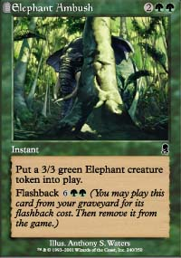
While powerful, Call of the Herd's sister spell will most likely stay in Limited.
Call of the Herd's other companions aren't quite as impressive, but they're still trouble. Chatter of the Squirrel only gives two 1/1s, but a creatureless deck is still faced with the same dilemma: Use a precious mass removal spell, or deal with them separately. Elephant Ambush is an instant creature, and eventually it too becomes a double threat. The game plan of many control decks gives the aggressive player plenty of time to get to eight mana. Still, this one is primarily a Limited version of the Constructed flashback cards. Roar of the Wurm is a special case, because the best way to use it is to discard it and then pay its flashback cost. There are other flashback cards, and they all present an aspect of the same problem, but the other ones with the kind of effects an anti-control player would want to protect aren't costed as aggressively. As usual, it's not just that the effect is powerful or well-suited to the situation, it's that it got the special touch that's given to the cards selected for tournament-level Constructed play.
A pure control, permanentless attempt to stop these cards will fail without some source of continuous card economy, and that too requires permanents. It's been a long time since Whispers of the Muse. That means that for a control deck to put up a fight it's going to have to resort to active defense in the form of its own permanents. That in turn means creating targets. Targets are a Bad ThingTM, but they've become necessary. Millstone is very much out of the picture if this matchup is still in play since it fills the opponent's graveyard full of evil flashback cards. That means the control decks also need a win condition. Nether Spirit was probably the best answer for all these problems, but it's gone.
The first option is to fight the good fight with creatures. An active defense could use dominating creatures like Spiritmonger, or it could try for Opposition. The problem is both these options lead into different decks. Commit to these types of cards and the traditional advantages of pure control decks are in large part gone. Opposition decks aren't control decks, they're Opposition decks. Killing with Spiritmonger means going through just about everything, and defending with one means tapping out in the middle game for a creature. Terminate and Exclude go from the deck's best friends to serious problems. Even cards like Repulse are suddenly very problematic. This is the type of control typical of block decks, and historically it has failed in Standard.
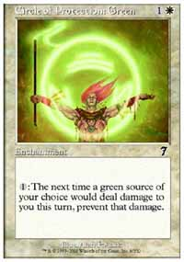
There is one strategy that has a legitimate chance of dealing with the problem, which is to return to Circle of Protection: Green and similar dedicated defenses, but that means giving up game one and hoping to keep a specific card in play. It's still just one matchup, but it leaves the problem of a win condition. There really isn't a good one anymore. In general the kill as such isn't a problem, since the win and the kill are separate. It's just slightly annoying, forcing decks to play cards like Millstone. Legacy Weapon was already a serious threat to that strategy, and I suspect it scared away a lot of people from playing white-blue control in the final days of the old Standard. That fear was irrational, since very few people actually used the card, but control players hate to be helpless.
Scary as it sounds, Millstone may still be the best option. Mahamoti Djinn was on the rise, but Thwart and Foil were an integral part of that plan. Without them, the Djinn is restricted to use as a transformation sideboard and similar strategies. Otherwise it will take forever for the Djinn to become playable. Millstone still works except when it doesn't. Against everyone without flashback or Legacy Weapon, it does its job quite well. Against Legacy Weapon, there are fixes. Opportunity is one example of a good solution, if this is a serious concern. It fits right into the deck. Against flashback decks, game one has to basically be given up. The deck can then transform to a different win condition and use defenses like the Circle of Protection: Green to try and salvage what used to be an easy matchup.
To balance that, the old problems for the deck type are now mostly gone. The free counters Thwart, Foil and Misdirection are no longer around to force through spells. A new Opposition deck won't have Gush or the ability to force through its spells, so it's safe to say that that's probably no longer a bad matchup. Other control decks have lost Nether Spirit, but it's totally unclear which way such battles will go. In general, players will be forced by these same considerations back upon creature decks, because there are fewer tools for non-creature decks available than in any previous Standard format. That's where pure control wants to be, since it can then focus with less risk. It might even open the door to specialized pure anti-creature decks.
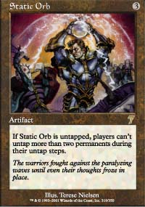
The flip side of what this does to control is how a flashback deck would do in other matchups. It stands to reason that against decks that try to fight it fair and square with creatures it would have an advantage over a similar pre-flashback deck for the simple reason that it can create more creatures from its spells, trade off and win with what's left. A Beast Attack facing off against a Shivan Wurm is in a fair fight, but Shivan Wurm is much more unwieldy in terms of deck requirements and risks of bad draws. If an Invasion Block-style deck faced a flashback one, game one would be a walkover. After sideboarding the other side would have weapons that could potentially match up, but those weapons should be more vulnerable. In short, a well-tuned flashback based deck should take out other creature decks with relative ease, barring hate. Given that it has now disposed of creature decks, probably of all sizes, and has dealt with control, it looks to be in a position to be an excellent deck. The one problem is that the mechanic isn't useful against Static Orb. There aren't as many tools as before to abuse the Static Orb, so the decks are fundamentally weaker, but so are all the other decks and the mechanic should be an even better idea now.
Flashback is the most powerful mechanic in Odyssey. That's not to say that there's nothing else of interest, but these are the cards that are most likely to make players rethink how they play Magic. They're so powerful that they seem out of place in what is otherwise a lower-powered set. The situation in Standard could start drifting toward a metagame where tokens are targeted by numerous bounce effects and graveyards become targets with four Cremates main deck in many black decks. It's also possible that these cards aren't as powerful as they first look, because they're vulnerable to the 'they just attack and block' problem.
Looking at the Invitational decks, which weren't available when I was writing the rest of the article, it is clear that Call of the Herd looks to become a staple card. Beast Attack is harder to use due to the green in its casting cost. As expected, the control decks fell back on creatures, with the star being Shadowmage Infiltrator. These cards ended up being paired with Opposition more than anything else, meaning that the new Opposition deck will indeed beat control due to its flashback cards instead of the previous strategies.

